Table 1. Survival of stream-type (ST) and ocean-type (OT) Chinook salmon at different stages of the experiment.
Diet |  | Sampling Stage for ST Chinook salmon
 |  | Stage 1:  5-Week Diet Trial In FW | 24-h post SWT | Stage 2:  4-Week Growth In SW
Control |  | 100% | 100% | 99 ± 1.3%
Treatment |  | 100% | 100% | 99 ± 1.3%
 |  | Sampling Stage for OT Chinook salmon
 |  | Stage 1:  5-Week Diet Trial In FW | 24-h post SWT | Stage 2:  4-Week Growth In SW
Control |  | 100% | 100% | 100%
Treatment |  | 99 ± 0.6% | 100% | 91 ± 7.6%
Values are expressed as mean ± standard error of mean (SEM). FW: freshwater; SWT: seawater transition; SW: seawater.

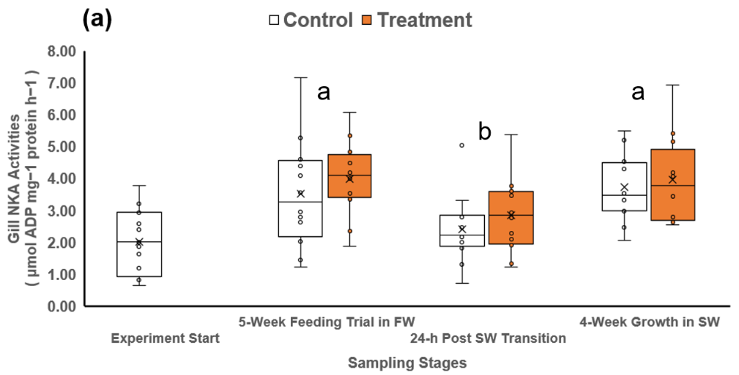

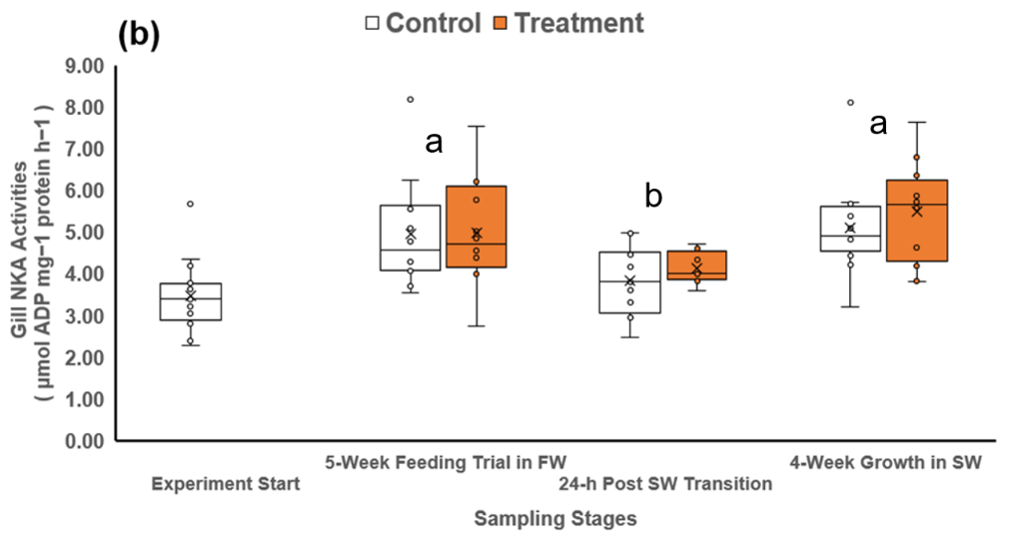
Figure 1. Gill Na⁺ K⁺ ATPase (NKA) activities of (a) stream-type chinook salmon, and (b) ocean-type chinook salmon from the control or treatment diet group at different experiment stages (n = 12 per sampling time per diet group). The cross symbol (×) in the box plot indicates mean values within each group. Different superscripts denote significant differences among each sampling stage (p < 0.05, two-way ANOVA, followed by all pairwise multiple comparison tests with the Holm-Sidak method).

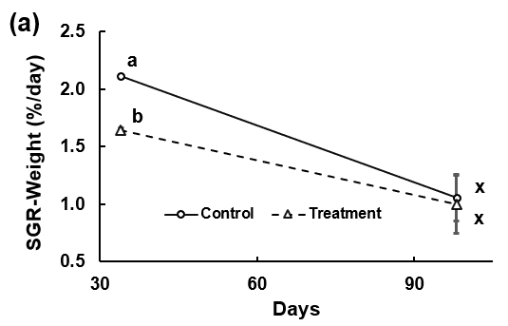
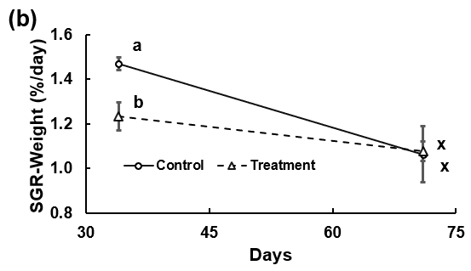
Figure 2. The mean specific-growth rates (SGR) of (a) stream-type (ST) Chinook salmon, and (b) ocean-type (OT) Chinook salmon from the control or treatment diet group at the end of the freshwater growth trial (day 34) and seawater growth trial (ST = day 98; OT = day 71) There was a significant interaction between diet and sampling stage on the SGR of both ST and OT chinook. Different superscripts denote significant differences between data within the each experiment stage (p < 0.05, two-way ANOVA, followed by all pairwise multiple comparison tests with the Holm-Sidak method). The error bars indicated standard error of the mean (SEM).

